REGISTRATION
SSD BASIC TRAINING ONLINE COURSE
Please photocopy for additional registrations.
Participant:________________________
Address:___________________________
__________________________________
Phone:____________________________
Fax:______________________________
Email:____________________________

PAYMENT
($200.00 per person for the course)
PAYMENT INFORMATION:
Phone In or Fax Your Registration:
Phone: 618-526-2588
Fax: 618-526-2592
Mail Check Payments to:
Outcome Services of Illinois
630 North 3rd Street
Breese, IL 62230
Credit card payment is available; please contact our office at 618-526-2588 for information.
****************************************
OFFICE USE ONLY
Check #_______ Date _______

ATTENTION: SOCIAL SERVICE DEPARTMENT

INTRODUCING…
SSD BAsic
Training Correspondence Course

August 11, 2005
&
August 25, 2005
August 11, 2005
&
August 25, 2005

***********************
Sponsored by:
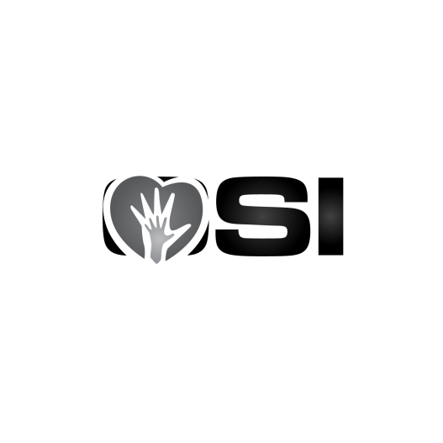
Tel: 618-526-2588
Fax: 618-526-2592
osioffice@outcomeservices.com

SSD BASIC TRAINING

This correspondence course will focus on identifying the overall responsibilities and expectations of a social service director in long-term care. It will include:
- Training on the Social Service Department’s role with assessments, policies and an understanding of the forms and documentation requirements.
- The Advance Directive process, with special emphasis on the POLST and end-of-life care.
- Regulatory changes impacting social services.
- Tools to assist you in providing trauma-centered care.
- Overview of the MDS for those sections pertaining to social services. These sections include A, B, C, D, E, Q and S.
- The interview processes are a critical component of the MDS 3.0. We will provide tips for interviewing along with guidelines and suggestions for completing the interviews.

- How the MDS/CAA leads into care planning.
- An overview of baseline care plans and person-centered care plans will be given along with what needs to be in place to make care plans person-centered.
- The PDPM program - information on social services’ role in this program will be provided.
- Behavior tracking is an important part of documentation from a behavioral health regulation and psychotropic medication standpoint. We will discuss the role of behavior tracking in your facility and ways to ensure the data you collect is accurate.

Speakers
This training course is taught by the staff of Outcome Services of Illinois. Our approach provides participants with a great opportunity to learn from consultants who work hands-on with staff in the nursing home.

GENERAL INFORMATION

This course consists of several modules including:

- SS Admission Process
- SS Documentation
- MDS Process
- RAI/CAA Process
- Trauma-informed Care
- Advance Directives
- Grievances
- Resident Rights
- Abuse
- Behavior Tracking
- PDPM
- Discharge Planning

Who Should Register?
- New SSDs in long term care nursing
- SSDs & Assistants needing a refresher course
- Care Plan Coordinators
- Administrators

COST: $200.00 per person 12.5 CEUs
*Administrator, Social Work, and Nursing CEUs provided*

